1) World Applied Sciences Journal (WASJ) ISSN 1818-4952
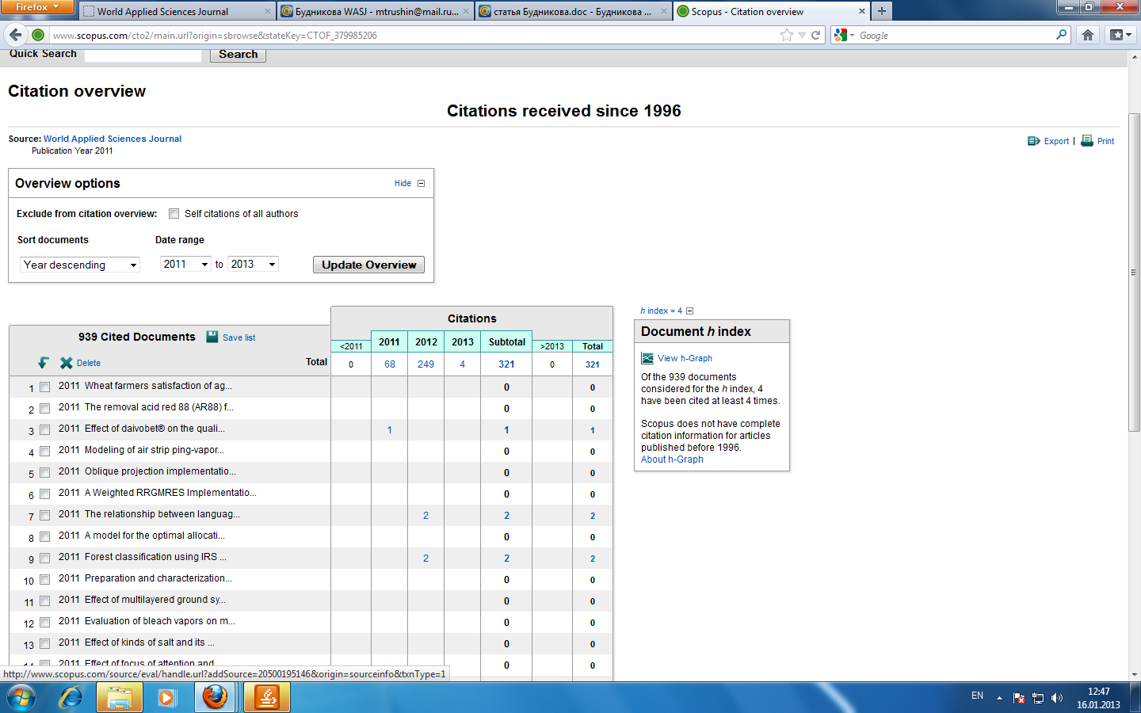
2) Middle East Journal of Scientific Research (MEJSR) ISSN 1990-9233
